VLSI Design Internship – Task 2 Report
Topic: Introduction to Verilog HDL and RTL Design of Basic Combinational Circuits.
Name: HARSH SAXENA
College: USICT (GGSIPU)
Date: 15/07/26

Objective
OBJECTIVE & EXECUTIVE SUMMARY
This report documents the design, implementation, and functional verification of basic combinational logic circuits using Verilog HDL at the Register Transfer Level (RTL). The primary objective of Task 2 is to demonstrate proficiency in writing synthesizable Verilog code for logic gates, Half Adder, and Full Adder modules, and validating their logic behavior using testbench execution and timing waveform analysis.

Key Project Deliverables:
• RTL implementation of basic logic gates (AND, OR, NOT, NAND, NOR, XOR).
• RTL behavioral modeling of Half Adder and Full Adder circuits.
• Development of complete testbenches applying all input combinations.
• Functional validation via timing waveform simulation files

Introduction to Verilog HDL
Verilog HDL is a Hardware Description Language used to model and design digital circuits. It allows designers to describe hardware behavior and structure at the Register Transfer Level (RTL). Verilog is widely used for FPGA and ASIC design because it supports simulation, verification, and synthesis.

RTL Design
RTL (Register Transfer Level) describes the flow of digital data between registers and the logical operations performed on that data. In combinational circuits, outputs depend only on present inputs.

Basic Logic Gates
AND Gate: Outputs a high signal (1) only if all of its inputs are high (1). If any input is low (0), the output is 0
OR Gate: Outputs a high signal (1) if at least one input is high (1). It outputs 0 only when all inputs are low (0).
NOT Gate: Also known as an inverter, it takes a single input and reverses its state. A 1 input becomes 0, and a 0 input becomes 1
Universal and Special Gates
NAND Gate: An AND gate followed by a NOT gate. It outputs 0 only when all inputs are 1; otherwise, it outputs 1. It is called a universal gate because you can build any logic circuit using only NAND gates.
NOR Gate: An OR gate followed by a NOT gate. It outputs 1 only when all inputs are 0. Like NAND, it is a universal gate.
XOR (Exclusive OR) Gate: Outputs 1 only when the inputs are different from each other (0 and 1, or 1 and 0).
XNOR (Exclusive NOR) Gate: Outputs 1 when both inputs are the same (0 and 0, or 1 and 1).

Half Adder
A half adder is a basic combinational circuit that adds two single-bit binary inputs (A and B) to produce a SUM using an XOR gate and a CARRY using an AND gate, without considering any carry-in from a previous stage.
1. binary addition of two single-bit inputs, generating a SUM (A ⊕ B) and CARRY (A · B).
2. Cannot handle carry-in from a previous stage, making it suitable only for the first stage of multi-bit addition.
Full Adder
A Full Adder is a combinational circuit that adds three inputs and produces two outputs. The first two inputs are A and B and the third input is an input carry as C-IN. The output carry is designated as C-OUT and the normal output is designated as S which is SUM.
1). The C-OUT is also known as the majority 1's detector, whose output goes high when more than one input is high.
2). A full adder logic is designed in such a manner that can take eight inputs together to create a byte-wide adder and cascade the carry bit from one adder to another.
3). We use a full adder because when a carry-in bit is available, another 1-bit adder must be used since a 1-bit half-adder does not take a carry-in bit.
4). A 1-bit full adder adds three operands and generates 2-bit results.

Simulation results:

1.) Half Adder simulation:

TRUTH TABLE:
Time (ns) | A | B | Sum | Carry
0–10 | 0 | 0 | 0 | 0
10–20 | 0 | 1 | 1 | 0
20–30 | 1 | 0 | 1 | 0
30–40 | 1 | 1 | 0 | 1

Simulation Result:
The Verilog code for the Half Adder was successfully compiled and simulated using Icarus Verilog. The output waveform was viewed in GTK Wave. The simulation verifies that the Half Adder performs XOR operation for the Sum output and AND operation for the Carry output. The observed waveform matches the expected truth table for all four input combinations.

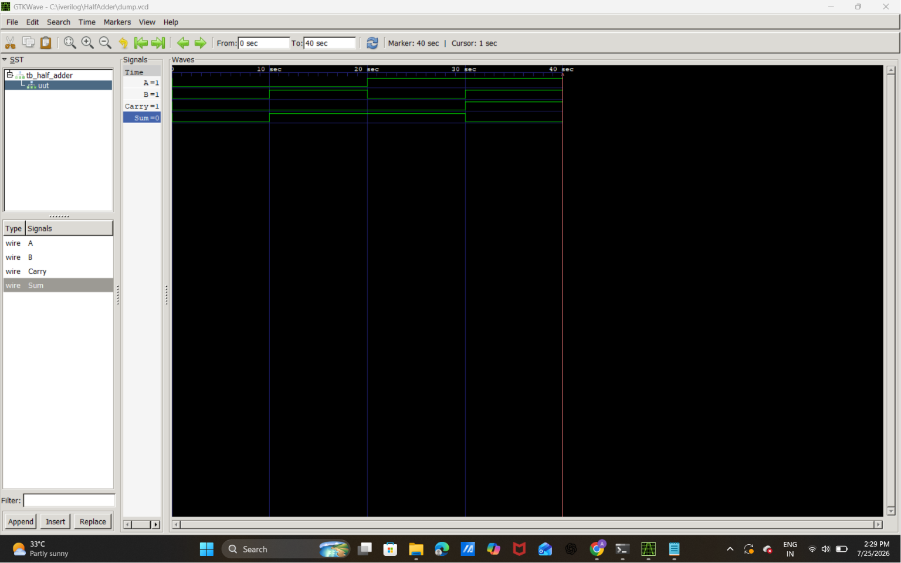

2.)Full adder

Truth Table
A | B | Cin | Sum | Carry
0 | 0 | 0 | 0 | 0
0 | 0 | 1 | 1 | 0
0 | 1 | 0 | 1 | 0
0 | 1 | 1 | 0 | 1
1 | 0 | 0 | 1 | 0
1 | 0 | 1 | 0 | 1
1 | 1 | 0 | 0 | 1
1 | 1 | 1 | 1 | 1

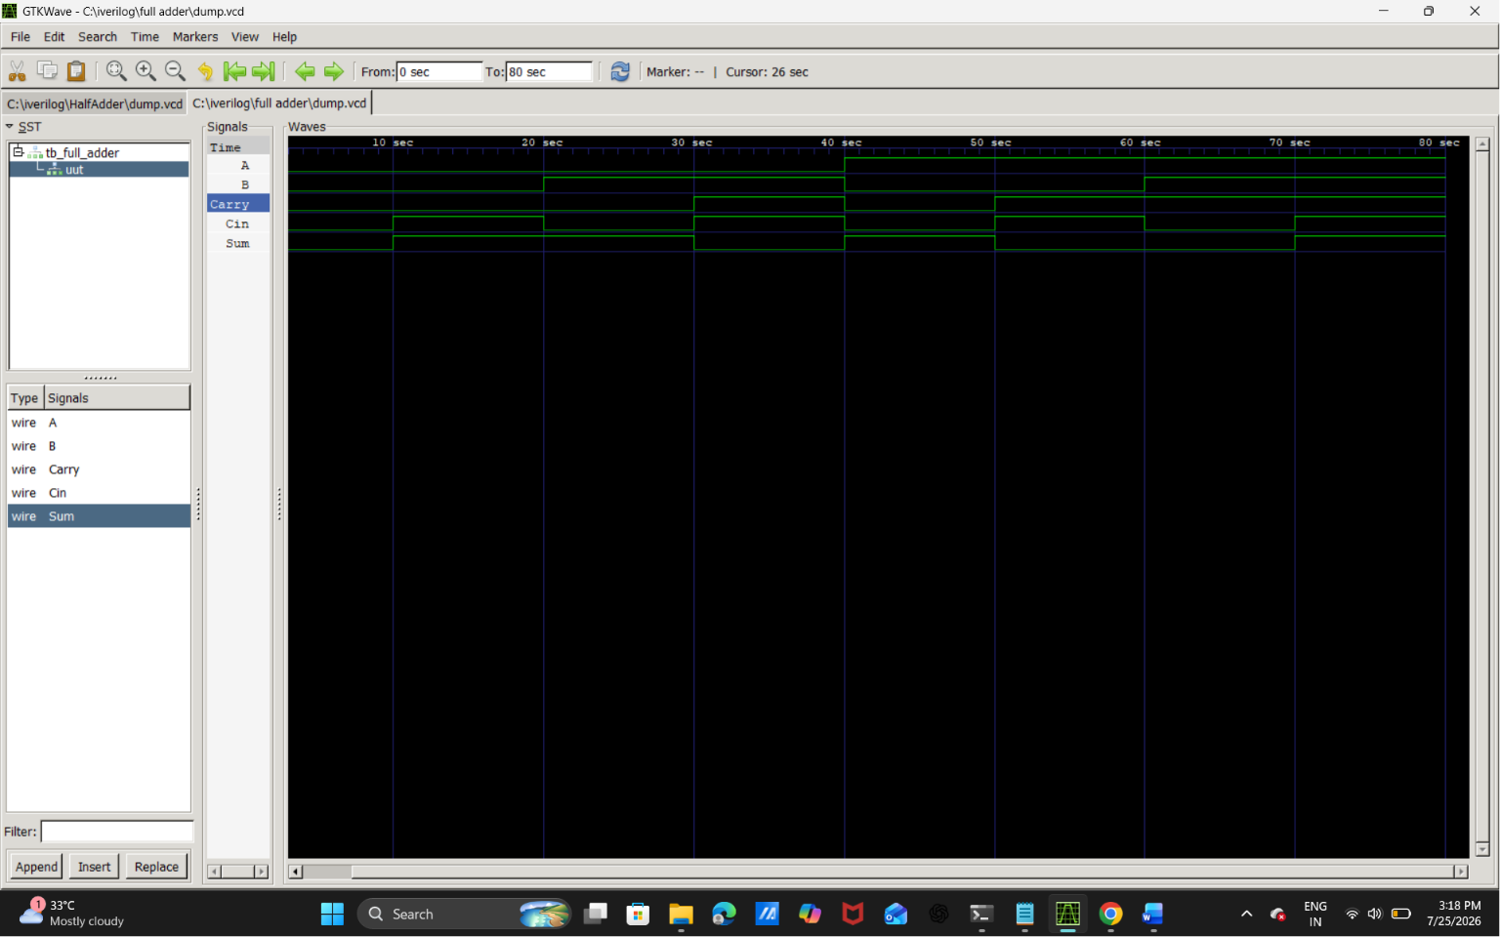

Logic gates

Gate | Boolean Expression | Description
AND | Y = A & B | Output is 1 only when both inputs are 1.
OR | Y = A | B | Output is 1 if at least one input is 1.
NOT | Y = ~A | Produces the complement of the input.
NAND | Y = ~(A & B) | Complement of AND gate.
NOR | Y = ~(A | B) | Complement of OR gate.
XOR | Y = A ^ B | Output is 1 when inputs are different.
XNOR | Y = ~(A ^ B) | Output is 1 when inputs are the same.

A | B | AND | OR | NOT A | NAND | NOR | XOR | XNOR
0 | 0 | 0 | 0 | 1 | 1 | 1 | 0 | 1
0 | 1 | 0 | 1 | 1 | 1 | 0 | 1 | 0
1 | 0 | 0 | 1 | 0 | 1 | 0 | 1 | 0
1 | 1 | 1 | 1 | 0 | 0 | 0 | 0 | 1

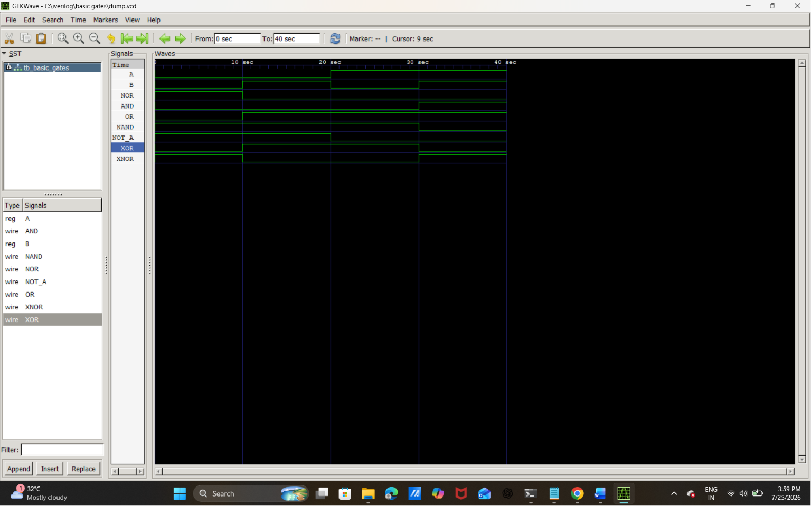

Conclusion
The Verilog modules for logic gates, Half Adder and Full Adder were implemented successfully. Testbenches verified the functionality through simulation. The generated outputs matched the expected truth tables, demonstrating correct RTL implementation.

